Back to Office Field Monitoring Visit Report
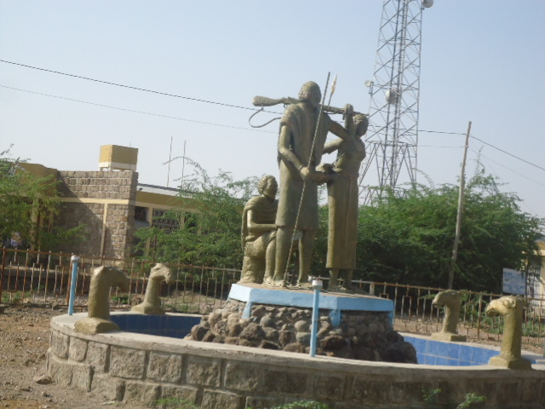
Afar Regional State, Amibara Woreda-Andido
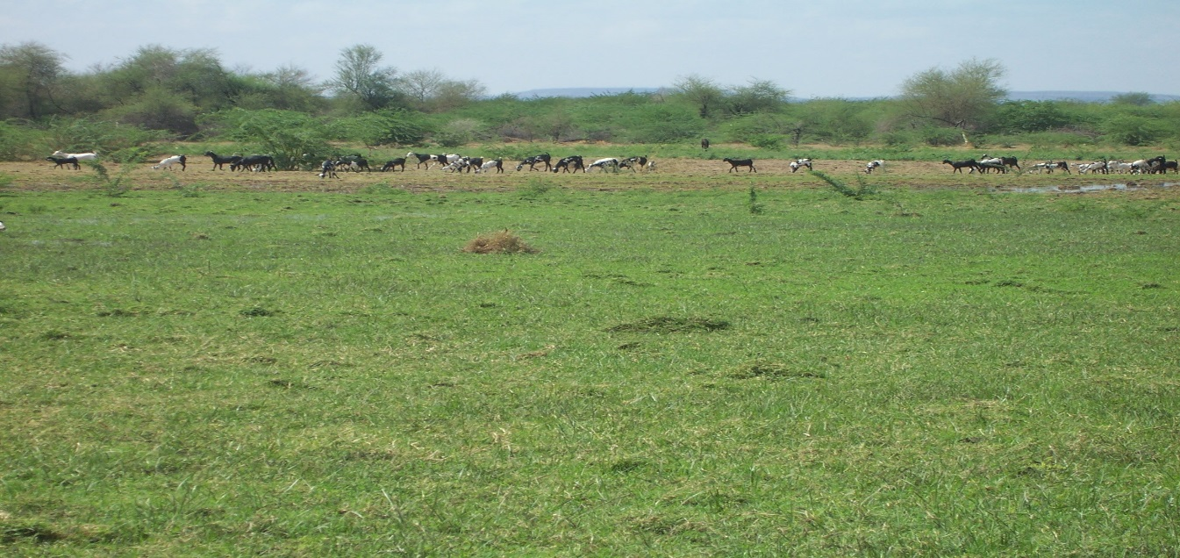
Assaita Woreda, Rehabilitation of Range Grassland
Members of the mission:- Yimer Hassen  Programme Implementation Support Officer (PISO) | Mission Date: October 13-23/2014
I. Places visited  Afar Regional State  - Bureau of Finance and Economic Development (BoFED)  - Afar-Environmental Protection, Land-use & Administration Agency  - Amibara Woreda Pastoralist Office  - Assaita Woreda Pastoralist Office  - Megale Woreda Pastoralist Office  Tigray Regional State  - Alamata City Administration  Amhara Regional State  - Dessie City Administration  - Debre Birhan City Administration  III- Objectives of the Mission  - To conduct financial document review 0f DRS, DRR, LED, CD and UN Flagship Gender Joint Programme projects.  - Delivery acceleration of DRR and Afar Integrated Dry land Management  - Coordinating and supporting of LED Project fixed asset handover and reconciliation activities | II. Project & Project ID:  - Capacity Development for Service Delivery (DRS)-74876,  - Strengthening Capacities for Disaster Risk Reduction & Livelihood Recovery-(DRR-74542),  - Afar Integrated Dry Land Management (AIDLM)- 77187,  - Local Economic Development (LED)-82517  - Capacity Development for Effective Coordination & Implementation (CD)-75671)  - UN Flagship Gender Joint Programme-(77285)
Officials met & counter parts discussed with:
BoFED:
- Ato Ausman Mekbul- BoFED Head, 0911-795241
- .Ato Jemal Nur-DRS Program Technical Expert, 0911-783911
- Ato Idris Kedir, Finance Officer, 0912-859237

DRMFSS Afar Coordination Office
- Abdeta Debela, UNDP DRR Project Coordination Office
- Mohammed Hussien, Finance Officer, 0910-36412
Afar-Environmental-Protection,Land-use-& Administration Agency
- Ato Elema Abubeker-Bureau Head-0912-301052
- Ato Assefa Biru, Regional Focal Person AIDLM Project, 0911-852030
Amibara Woreda
- .Ato Ali Hussien, Ali-Woreda OFED Head-0911-680369
- Ato Besifat Assefa, Finance Officer-0920100800

Assaita Woreda
- Ato Abubeker Mohammed Ali-Woreda OFED Head, 0911407420
- Ato Hassen Yesuf, OFED Finance Officer 0910-350807

Megale Woreda
- Ato Omer Ahmed,Pastoral & Agricu. Head-0937-00-09-75
- Ato Berhanu Tigabu,WoFED Programme Coordinator 0914-14-32-84
Alamata City administration
- Ato G/Tensae Fiseha, City Manager
- Ato Girmay G/Egziabher, LED Expert, 0919042941
- Ato Redae Abreha, Finance Officer, 0914785321
Dessie City Administration
- Ato Alebachew Yesus, City Mayor-0930-072314
- Ato Jillal Hussien , LED Expert, 0331127202, 0913-940665
- W/ro Mulu Abate, Finance Officer-0914735521
Debre Birhan City Administration
- Ato Getaneh Zike, City Mayor-0911576022
- Ato Masresha Yekoyesew, LED Expert-0912-847366

IV- Major Tasks Performed
- Conducting financial document review of DRS, DRR, LED, UN Flagship and CD projects at Afar BoFED, Afar DRMFSS Coordination Office, Amibara and Megale Worewda WoFEDs, Alamata, Dessie and Debre Birhan City Administrations
- Coordinate and pushing or facilitating delivery for the remaining amount of unsettled amount of Birr 1,314,672.04 for Afar Integrated Dry Land management and DRR projects
- Conducting discussions with Afar Regional State BOFED Head, Amibara WoFED Head and Megale Woreda WoFED and Pastoral and Agricultural Head on the financial document review findings of DRS project and actions to be taken before NIM audit commencement (Below is the table for the Document review findings & recommendations)
- Discussions held with Alamata, Dessie and Debre Birhan city Administrations’ City mayors and appropriate officials about LED project Fixed Asset reconciliation for the closure of the project (Below is the table for the Document review findings & recommendations)
- Discussions on the table was conducted with the appropriate programme units responsible officers to follow up the issues before 2013 NIM audit commences
V. Detail Document review data for all Projects
Total fund transfer from UNDP and FACE amount sent from IP’s for all the projects mentioned in the first page are reconciled and errors corrected.

A) DRS Project (74876):
All fixed assets procured from Jan 1,2014 to date in BoFED, Amibara, Assaita and Megale Woredas is recorded and updated into their fixed asset register and Summarized
Total fund transfer from UNDP and FACE amount sent from IP’s is reconciled and errors are corrected.
- Afar BoFED
Total Transfer from Jan. 01/2014 to date-----------------------------------------------------Birr 1,848,518.78
Total Settlement ------------------------------------------------------------------------------------ Birr 1,848,518.78
- Amibara Woreda DRS Project
Total Transfer from Jan. 01/2014 to date ---------------------------------------------------- Birr 967,709.12
Total Settlement ------------------------------------------------------------------------------------ Birr 967,709.12
- Assaita Woreda DRS Project
Total Transfer & Bal. from Jan. 01/2014 to date ------------------------------------------- Birr 897,507.64
Total Settlement ------------------------------------------------------------------------------------ Birr 897,507.64
- Megale Woreda DRS Project
Total Transfer & Bal. from Jan. 01/2014 to date -------------------------------------------- Birr 668,105.21
Total Settlement ------------------------------------------------------------------------------------ Birr 668,105.21

B) DRR Project (74542)

DRMFSS Coordination office
The only fund settled and implemented was for Birr 78,696.00 for conducting DRM policy & Regional specific familiarization workshop and the appropriate supporting document is reviewed.
Total Transfer & Bal. from Jan. 01/2014 to date ----------------------------------------------- Birr 363,969.00
Total Settlement ---------------------------------------------------------------------------------------Birr 78,696.00
Unsettled Amount--------------------------------------------------------------------------------------Birr 285,273.00
C) LED Project (82015)

Discussions held with Alamata, Dessie and Debre Birhan city Administrations’ Mayors and appropriate officials about LED project Fixed Asset reconciliation for the closure of the project. All the expenditure and the supporting document of the project for the three City administrations is reviewed.
- Alamata City Administration
Total Transfer & Bal. from Jan. 01/2014 to date ----------------------------------------------- Birr 388,099.50
Total Settlement ---------------------------------------------------------------------------------------Birr 388,099.50
- Dessie City Administration
Total Transfer & Bal. from Jan. 01/2014 to date ------------------------------------------------ Birr 968,591.94
Total Settlement ---------------------------------------------------------------------------------------Birr 968,591.94
- Debre Birhan City Administration
Total Transfer & bal. from Jan. 01/2014 to date ------------------------------------------------ Birr 899,351.95
Total Settlement ---------------------------------------------------------------------------------------Birr 899,351.95
D) Afar Integrated Dry Land Management (77187)

Afar-Environmental-Protection, Land-use-& Administration Agency
Birr 888,250.87 was transferred from UNDP on Sept. 2,2014 and Afar BoFED also transferred the same amount to Afar-Environmental-Protection, Land-use-& Administration Agency on Sept. 17, 2014. The fund is not yet expended and the programme is implemented and finalized up to Dec. 31, 2014
Total Transfer & Bal. from Jan. 01/2014 to date ---------------------------------------------- Birr 892,750.87
Total Refund---------------------------------------------------------------------------------------------Birr 4,500.00
Unsettled Amount ------------------------------------------------------------------------------------Birr 888,250.87

E) Capacity Development for Effective Coordination and Im[plementation (75671)
Total Transfer & bal. from Jan. 01/2014 to date ------------------------------------------------ Birr 581,984.37
Total Settlement ---------------------------------------------------------------------------------------Birr 519,532.20
Unsettled amount 62,452.17
F) UN Flagship Gender Joint Programme (77285)

Total Transfer & bal. from Jan. 01/2014 to date ------------------------------------------------ Birr 116,623.32
Total Settlement ---------------------------------------------------------------------------------------Birr 116,623.32
The supporting document has not been available in BoFED and the finance officer in Regional Bureau of Women and Youth affairs was not around and no review work has been conducted for the expenditure reported by FACE.

VI. Financial Document Review Findings & Recommendations:
Below is attached in summary format the financial document review findings and recommendations with the corresponding risk level.

VI. Conclusion and Recommendation:
- Most of the activities implemented include DSA as major part of the expenditure in majority of the activities which is not justifiable and will minimize the objectives and goal of the project that is targeted to minimize the disaster risk of the pastoral communities. Therefore, strict monitoring and orientation has to be conducted.
- Capacity building trainings should be given regarding financial and procurement management/operational.

Reported By--------------------------------------------------------------------------------------------------Yimer Hassen

1. DRS Project Financial Document Review Findings & Recommendations
1.1 Amibara Woreda
1.1.1 Livelihood component of Birr 580,249.11 from the second transfer
# | Activity Description & amount authorized | Comments and Findings | Risk Level | Actions Taken | Recommendations
1 | Birr 66,864.76  Small scale irrigation crop seed multiplication at Halidaebi Kebele (Amibara Woreda) | -Request for the procurement has not been attached  -Goods Receiving Note (Model 19) and Goods Issuing Voucher/distribution list (Model 22) has not been attached  -Receipt from Revenue Authority has not been attached for the Income tax deducted from daily labors | High | - Discussion held and agreed to attach purchase request, GRN, GIS voucher and Income Tax receipt | Model 19 and model 22 should be always to be used for goods procured and issued and income tax deductions should be paid to Tax Authority on monthly basis and receipt has to be attached with payroll
2 | Birr 106,827.76  Procure improved seeds for 50 hectare of cultivated lands and support fodder production (other agricultllnal input like hand tools. (Amibra) | - Request for the procurement has not been attached  -Goods Receiving Note (Model 19) and Goods Issuing Voucher/distribution list (Model 22) has not been attached  -Purchase committee minute or justification for the procurement has not been attached | High | -Discussion held and agreed to correct and attach all the missing documents | GRN (Model 19) and Goods Issue Voucher (model 22) should be always to be used for goods procured and issued/distribution list
3 | Birr 154,297.73  Provide Training and certification on training | -Attendance sheet for the staffs who took the training has not been attached | Medium | - Discussion held and agreed to attach the attendance sheet | Every training and workshop should be corroborated by TOR and attendance sheet
4 | Birr 66,880.94  Fodder seed multiplication for Halidaebi Kebele | -Receipt from Revenue Authority has not been attached for the Income tax deducted from daily laborers | High | Discussion held and agreed to attach the income tax receipt | Income tax deductions should be paid to Tax authority on monthly basis and receipt has to be attached with payroll
5 | Birr 120,000.00  Preparation of land & construction of irrigation land | -Work time sheet for deployed Excavator machine and certification of the work for Birr 89,838.00 has not been attached | High | Discussion held and agreed to prepare and attach the time sheet and certificate of the work for payment | Such kind of services, renting of vehicles and the like should have date and time record and the final summary certified for payment
6 | Birr 31,484.37  Conduct 5 days training on improve goal fattening production techniques for 60 pastoralists selecled from 5 kebeles | -Attendance sheet for the staffs who took the training has not been attached | Medium | - Discussion held and agreed to attach the attendance sheet | Every training and workshop should be corroborated by TOR and attendance sheet

1.1.2 Governance component of Birr 269,061.52 from the second transfer
# | Activity Description & amount authorized | Comments and Findings | Risk Level | Actions Taken | Recommendations
1 | Birr 30,000.00  Organize awareness creation event on the revenue generation and lCT for higher officials 1 regional, and Woreda experts and concerned stakeholders and disseminate the result at Regional and All DRS Woreda level | -The activity is organizing awareness creation but the amount is expended for the procurement of 2 (two) laptops | High | - Discussion held and agreed to attach reprogramming letter and the Lap Top Computers have to be recorded on Non-Expendable Fixed Asset Register book | Reprogramming has to be requested and authorized from UNDP Programme Unit for activities out of AWPs
2 | Birr 50,791.07  Training for newly elected  Woreda Council members on the role and responsibility of Woreda council | -Attendance sheet for the staffs who took the training has not been attached | Medium | - Discussion held and agreed to attach the attendance sheet | Every training and workshop should be corroborated by TOR and attendance sheet
3 | Birr 51,515.92,  Establishment of permanent regular & quality local office structure and service through providing necessry office equipment and repairing works for five days | -Attendance sheet for the staffs who took the training has not been attached | Medium | - Discussion held and agreed to attach the attendance sheet | Every training and workshop should be corroborated by TOR and attendance sheet
4 | Birr 51,515.92  Officials and experts on the roles and responsibilities of Woredas and kebeles council members in the preparation and approval of plan for five days | -Attendance sheet for the staffs who took the training has not been attached | Medium | - Discussion held and agreed to attach the attendance sheet | Every training and workshop should be corroborated by TOR and attendance sheet
5 | Birr 69,326.29  Raise awareness of worecla and kcbclc officials and clan leaders ,pastoralist community memebrs and justice bodies on conflict prevention and management for five days | -Attendance sheet for the staffs who took the training has not been attached | Medium | - Discussion held and agreed to attach the attendance sheet | Every training and workshop should be corroborated by TOR and attendance sheet

1.2. Assayita Woreda
1.2.1 Livelihood component of Birr 333,353.57, from the second transfer
# | Activity Description & amount authorized | Comments and Findings | Risk Level | Actions Taken | Recommendations
1 | 31,000.00  DSA transportation and vaccine supply for vaccination campaign against livestock (caws and camels) diseases in all 13 kebeles. | -Fuel expense recorded has not been supported by a receipt  -Receipt for fuel is not attached | high | -Agreed to find the receipt  and attached with the document | -Every expense should be supported by an official receipt
2 | Birr 87,563.55  Procurement and supply of veterinary drugs for all 13 kebeles of Assayita | -Distribution list or the issue voucher (model 22) of the procured drugs has not been attached | High | -Agreed to find and attach the distribution list and receipt with the supporting document | -Every expense should be supported by an official receipt and for issuing of goods there should be always issue voucher
3 | Birr 154,790.00  Provide agricultural input (improved fooder and other Seed, farm tools and water pump for 5 selected kebeles) berga, mamule, karadura, hinelle and Karbudda. | The internal control system is very weak  1)The receipt and signature for the procurement of Birr 16,000.00 for onion seed and Birr 40,000.00 for fodder seed from individual and community pastoralists is materially misstated and calculated  2)The payment form requires purchase committee members signature and no one signs on it and the approver and payer is the purchaser  3) Water pump amounting to Birr 29,840.00 was not recorded in the Non-Expendable Fixed Asset Register | High | -Agreed to correct and to sign by the committee members to reduce the weakness in the internal control system  -Agreed to record in the Fixed Asset Register Book | -For every payment there must be an internal control system in that one person should not act as requester, approver, payer and purchaser  -Every fixed asset procurement should be recorded with goods receiving note and on the Fixed asset Register
4 | Birr 60,000.00  Produce forest seedling at nursery site & plantation on defrosted area (Gllalo, Handeg,HenelIe,Ber.) | No receipt is attached for the Income tax deducted from daily laborers | High | -Agreed to pay to Revenue Authority and attach the receipt | -Income tax deducted should be paid always to Revenue Authority at end of month

1.2.2 Governance component of Birr 394,528.43, from the second transfer
# | Activity Description | Comments & Findings | Risk Level | Actions Taken | Recommendations
1 | Birr 70,000.00  Establishment of permanent regular & quality local office structure and serving through providing necessary office, equipment and repairing works for five office | -Procurement of Office Equipment amounting to Birr 69,048.00 has not been recorded in the Non-Expendable Fixed asset Register  -There is a difference of Birr 952.00 from the expenditure of Birr 69,048.00 and the money sent of Birr 70,000.00 | Medium | -Give details of the information to be recorded in the fixed asset register and agreed to finalize  -The difference of Birr 952.00 has to be expensed by procuring additional item to make nil | Every fixed asset procurement should be recorded with goods receiving note and on the Fixed asset Register
2 | Birr 15,912.50  Coordinating and conducting regular M&E of the programme by Regional and Woreda Steering Committee, Annual and Bi-annual Review Meeting | -Receipt of Birr 2,988.00 for printing has not been attached and there is a difference of additional Birr 88.82 between the expenditure recorded of Birr 15,823.50 and money sent Birr 15,912.32 | High | - Agreed to find the receipt  and attached with the document and procure additional items for Birr 88.82 | Every expense should be supported by an official receipt
3 | Birr 80,000.00  Procure lT materials for Woreda  Administration, WoFED to strengthen the information management system | - Procurement of IT Equipment amounting to Birr 69,700.00 has not been recorded in the Non-Expendable Fixed asset Register  -Birr 3,000.00 paid for procurement of Fan has no receipt and recorded with Goods Receiving note (model19) | High | - Give details of the information to be recorded in the fixed asset register and agreed to finalize | Every fixed asset procurement should be recorded immediately with goods receiving note and on the Fixed asset Register
4 | Birr 76,462.54  Facilitate experience sharing with other Woredas | Birr 66,150.00 DSA payment is paid without DSA format | Medium | Agreed to prepare the form and attach to the supporting document | -DSA payments should be paid by appropriate authorization of the DSA form
5 | Birr 30,000.00  Organize awareness creation event on the revenue generation and lCT for higher officials regional, and Woreda experts and concerned stakeholders and disseminate the result at Regional and All DRS Woreda level | -There is no any supporting document attached, only Voucher No. 950646, dated July 13/2014 is attached. | High | -Agreed to attach the settlement or DSA paid for the attendees of | -No FACE or FR should not be sent to UNDP without the settlement of the advances
1.3. BoFED Livelihood component of Birr 518,095.67, from the Second transfer
# | Activity Description | Comments & Findings | Risk level | Actions Taken | Recommendations
1 | Birr 120,000.00  procure lCT materials for program and Region officers | -Procurement of 7 Laptops and 2 Scanners amounting to Birr 125,399.98 has not been recorded and updated in the Fixed Asset Register  -Purchase committee members did not sign on the minute that is attached | Medium | - Discussion held and agreed to update and record in the Fixed Asset Register Book | Every fixed asset procurement should be recorded immediately with goods receiving note and on the Fixed asset Register

1.4. Megale Woreda
1.4.1 Livelihood Component of Birr 560,050.25, from the Second transfer
# | Activity Description | Comments & Findings | Risk Level | Actions Taken | Recommendations
1 | Birr 177,587.96  Protect forage production land from flood, erosion and construct with Gabion | -The expenditure amount is 176,477.10 and there is a difference of Birr 1,110.86, which should be expended  -Income tax from daily laborers has not been deducted  -Birr 22,522.10 paid for DSA for the procurement committee and people has no justification | High | - Discussion held and agreed to attach a receipt for the difference and supporting document has to be attached  -No action taken for the income tax but agreed to confirm in the future  -Discussion held including with DRS Technical Assistant at BoFED Level | -Income tax should be deducted from daily laborers payment above Birr 150.00 per month and to be paid the Tax Authority
2 | Birr 50,144.05  Provide improved forage seed for livestock marketing cooperative | -Birr 10,725.00 paid for DSA for the procurement committee and people has no justification | High | -Discussion held including with DRS Technical Assistant at BoFED Level and to give high consideration on such kind of irregularities | -More than 10% overhead cost is not reasonable and allowable on any programme of activity
3 | Birr 87,005.16  Provide and support improved small hand tools | Birr 39,804.50 (46%) is expended for DSA and transport to procure distribute Birr 47,200.00 amount of hand tools |  | -Discussion held including with DRS Technical Assistant at BoFED Level and to give high consideration on such kind of irregularities | -More than 10% overhead cost is not reasonable and allowable on any programme of activity
4 | Birr 30,000.00  Organize awareness creation event on the revenue generation and lCT for higher officials regional and Woreda experts and concerned stakeholders and disseminate the result at Regional and All DRS Woredas | -Receipt for Birr 1,125.00 of fuel has not been attached with the supporting document | High | - Discussion held and agreed to find the receipt  and attach with the document | - Every expense should be supported by an official receipt  - No FACE or FR should not be sent to UNDP without the settlement of the advances
5 | Birr 47,575.00  Organize five days awareness raising on conflict prevention management and resolution for Woreda and Kebele officials, clan leaders, pastoral community and justice | -There is a difference of Birr 4,319.00 between the supporting document of payment to DSA and the expenditure (which is over)  -Birr 575.00 has not been expended from the money sent | High | - Discussion held and agreed to correct and rectify the error  - Additional item of expenditure has to be recorded and to be attached | -Every expense should be supported by an official receipt or by the beneficiaries’ signature
6 | Birr 15,912.32  Coordinating and conducting regular M&E of the programme by Regional and Woreda Steering Committee, Annual and Bi-annual Review Meeting | - Receipt for Birr 897.32 of fuel has not been attached with the supporting document | High | - Discussion held and agreed to find the receipt  and attach with the document | -Every expense should be supported by an official receipt or by the beneficiaries’ signature

2. CD Project
# | Activity Description | Comments & Findings | Risk Level | Actions Taken | Recommendations
1 | Birr 519,532.20  Technical assistance/Salary for Finance Officers and support joint field monitoring and follow up to target Woredas | -Difference of Birr 1,800.00 is (over expenditure) with the supporting document ( Birr 517,732.20) and expenditure/FACE reported of Birr 519,532.20 , (from the two transfers) | Medium | - Discussion held and agreed to include additional item of expenditure to be recorded and attached | Every expense should be supported by an official receipt or by the beneficiaries’ signature

3. LED Project
Debre Birhan City Administration
# | Activity Description | Comments & Findings | Risk Level | Actions Taken | Recommendations
1 | Birr 84,199.00  Salary and M&E | -Birr 682.22 is over expenditure over and above the supporting document  -Income tax deducted from the LED Expert salary is not paid to the Tax Authority and attached with the supporting document | Medium | - Discussion held and agreed and agreed to correct | -Income tax deducted should be paid always to Revenue Authority at end of month

